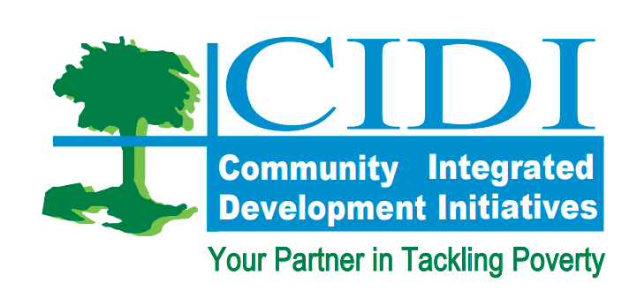
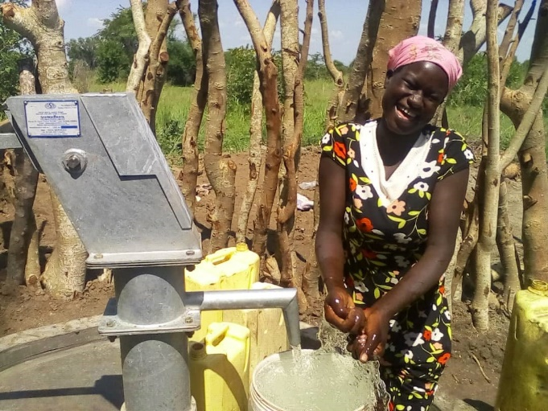
ANNUAL REPORT 2022
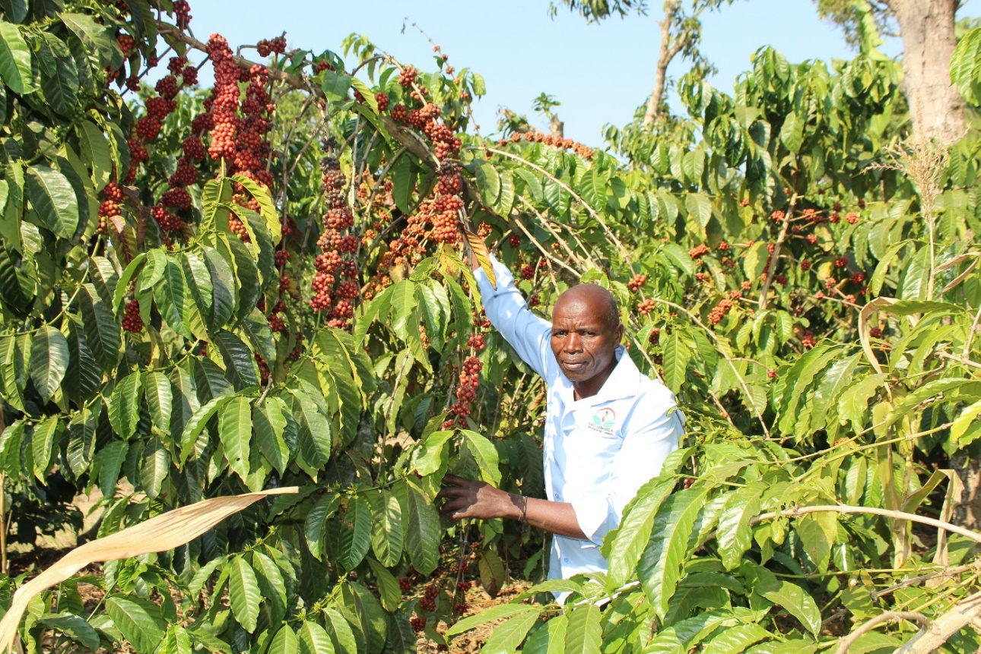

CIDI premises on the following Vision, Mission and Core values to execute her strategic agenda.

Communities enjoying a decent life free of hunger, poverty and disease.

Enhance sustainable community livelihoods through Income and food security, Water and Sanitation, good health and policy advocacy




Transparency, teamwork, community participation, result-oriented and integrity.

CIDI contributes to the following Sustainable Development Goals.

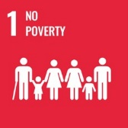
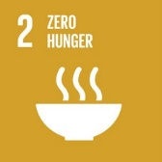
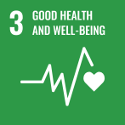
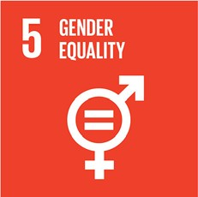
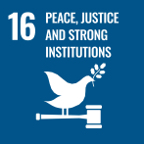

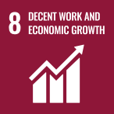
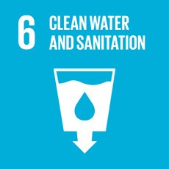

Introduction
The year 2022 was a fruitful one since CIDI was able to achieve big milestones. This report presents the outstanding achievements registered during the course of the year 2022 which were generally, in terms of the targets achieved, the new projects that emerged, the successful annual review of the annual operational plans, and 25 years celebrations. Community-Integrated Development Initiatives (CIDI) has continued to align its interventions with its strategic focus areas. This has guided its strategic direction and attainment of a number of strategic targets. These targets were derived from the overall strategic plan 2021-2025 but also from the gaps identified in the implementation of the 2021 annual operational plans. The report unfolds these key achievements recorded during the year 2022 across CIDI operations in Uganda and outside.
During the year 2022, CIDI celebrated 25 years since its founding in 1997. The organization has throughout those years legally operated under registration certificate No. 2715 and reference No. S-5914/2868. CIDI has a national operating license allowing her mandate to stretch operations across the country. CIDI has remained focused on her core program thematic areas of Agriculture, water and sanitation, Health promotion, Advocacy and good governance, and youth vocational skilling. CIDI’s focus priority is on the most disadvantaged communities in rural and urban areas including refugees.
CIDI operations are driven by the vision to have “Communities enjoying a decent life free of hunger, poverty and disease”. The Mission is to enhance sustainable community livelihoods through Income and food security, Water and Sanitation, good health and policy advocacy. The driving core values of CIDI are; Accountability and transparency, teamwork, community participation, result-oriented and integrity.
CIDI programs have continued to reach and address the very needs of the target communities/beneficiaries. Stakeholder involvement and participation in CIDI activities has been extremely supportive to the attainment of the achievements of the year.
A number of challenges emerged during the year and these partly affected some of the planned activities for the year 2022. These include; the high rates of inflation in the country which caused the fuel prices to hike indirectly affecting the prices of all other commodities.

2022 ACHIEVEMENTS IN NUMBERS


1,784
Beneficiary households attained improved incomes

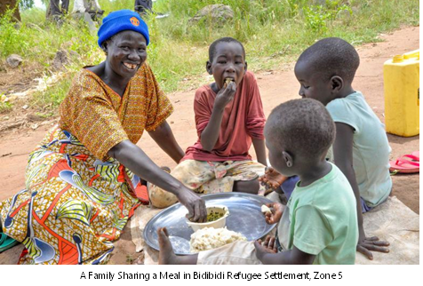
1,637
Beneficiary households able to access three meals per day

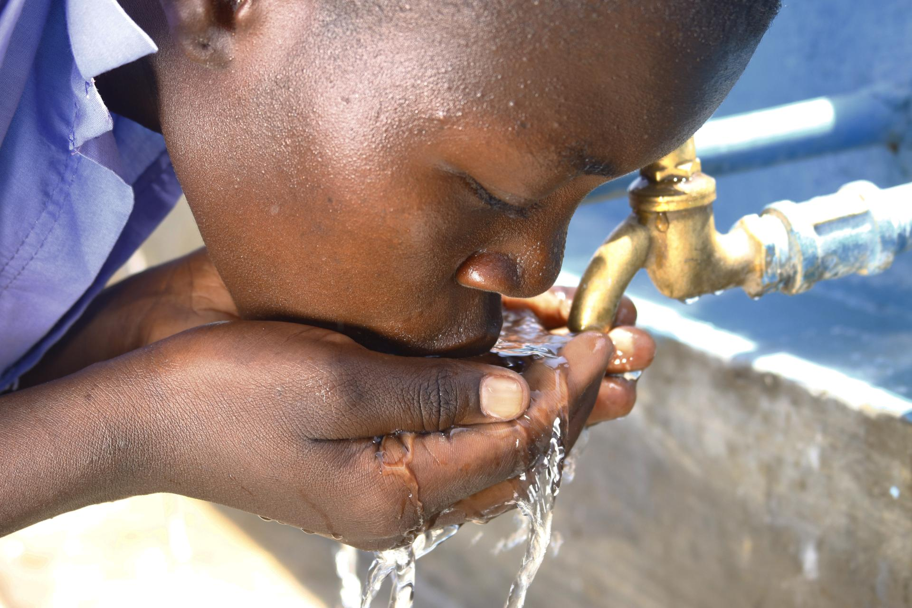
26,211
Beneficiaries supported with access to safe drinking water and improved sanitation services

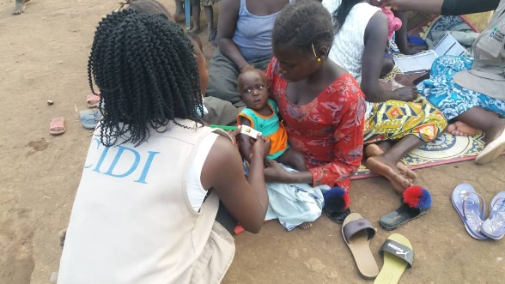
4,275
Beneficiary refugee households’ capacity built on good nutrition through home visits.

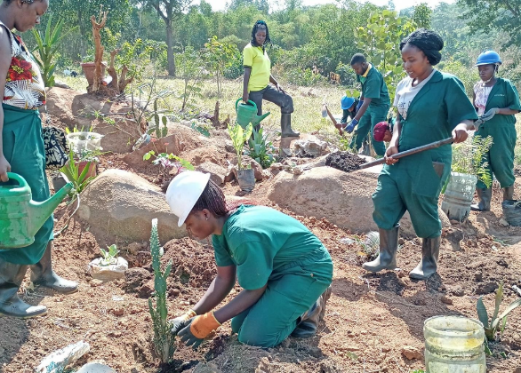
66: 32
students equipped with skills in garden and landscape designing for short and long-term courses respectively from CIDI-TCGL.

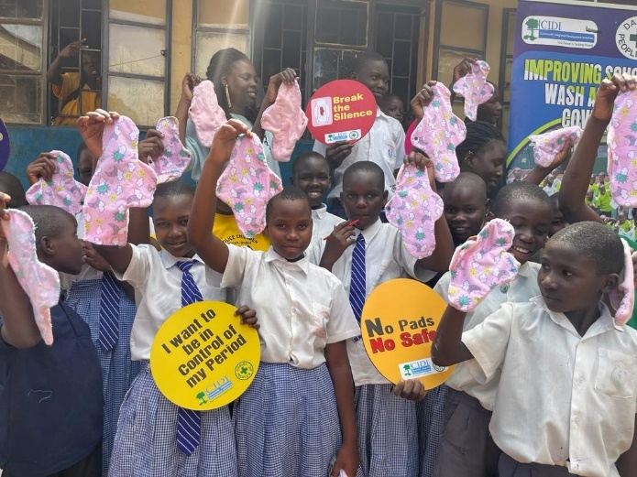
4,600 learners
(3,350 G, 1250 B, 80 with special needs)
had their capacity built in Menstrual Hygiene Management.

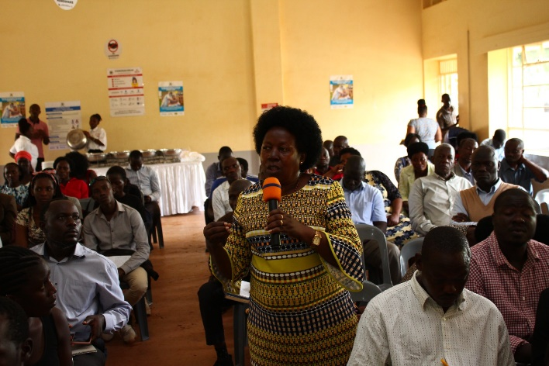
1,250
Duty bearers’ capacity built-in good governance and Human Rights Based Advocacy

KEY ACTIVITIES PER DEPARTMENT

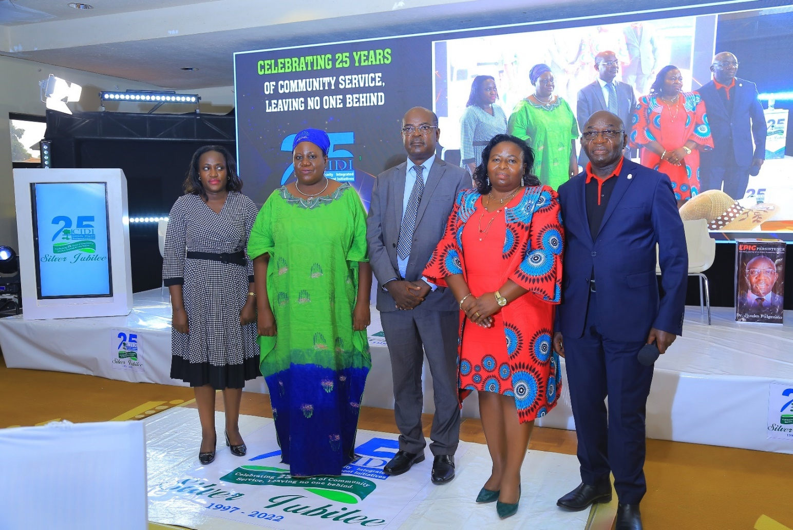
GOVERNANCE, MANAGEMENT, AND ADMINISTRATION.
THE CIDI BOARD OF GOVERNORS

In pursuance of the CIDI strategic plan objectives for 2022, the CIDI governance, management, and administration implemented a number of activities to achieve targets that were set for the year 2022. Governance, Management, and Administration of CIDI continued to focus on three key strategic objective areas;
Promoting the understanding of CIDI’s Vision, Mission, Core values and governance of the institution.
CIDI appreciates that the success of her operations can highly be propelled through a wider understanding of CIDI’s vision, mission and core values across board. For the reporting year, efforts were taken to popularize CIDI vision, mission and core values. This has been attained through various meetings internally and with stakeholders, CIDI website, social media platforms, wide and extensive dissemination and display (electronically, in print and media).
All CIDI official emails have been customized with the company vision, mission, and core values. This has enabled wide dissemination to key partners and stakeholders that CIDI collaborates with officially. The key governance bodies of CIDI (General Assembly and Board of Directors) have been successfully oriented and acquainted with the CIDI Vision, Mission and core values. Same orientation was extended to their better understanding of the CIDI strategic direction as defined in the current strategic plan 2021-2025. A recent assessment during CIDI annual review for 2022 registered a 90% good knowledge among members of the CIDI General Assembly and Board of Directors. It is appreciated that extra efforts are needed towards attainment of the100% knowledge among members in this respect.
Focused capacity strengthening was undertaken for all Board members in their oversight roles. Key among them was financial oversight, contractual approvals for new and renewed partnerships, annual budget and work plan reviews and approval as well as financial audit management. As a result, the year 2022 has witnessed one of the most vibrant involvements of the Board and the general assembly members in directing CIDI operations. Institutional Annual review for 2022 and planning and budgeting for 2023 were all promptly done. The general assembly fully sat, reviewed, guided and finally made approval for the annual report 2022, and annual plan and budgets for 2023. There were however a few anticipated Board activities earmarked for the year 2022 that were not achieved due to financial limitations. Those were not as significant to substantially affect the overall planned targets for 2022.
Strengthened CIDI internal Leadership and management in program implementation.
There have been great improvements that CIDI managed to realize for the Senior Management Team (SMT) in undertaking their oversight role. Management was severally involved in field support supervision across the seven CIDI branch offices distributed over Uganda. Progress review and planning for the running projects was core during this undertaking. Several (19) support supervision and monitoring visits have been conducted by the M&EL department as well as by the ED.
Board members were severally involved in providing technical support and guidance to the SMT. The top executive of CIDI has received tremendous support from the SMT in the routine management of the CIDI operations. 32/52 management meetings took place providing that supportive role to the executive.
Similar support has also been recorded from the management to the respective departments. Management has been successful in coming up with a disability inclusion assessment, planning and capacity enhancement strategy. These have been prioritized for operationalization under the year 2023 annual plan.
Strengthened CIDI collaboration and Networking with partners and stakeholders.
It was a core action for CIDI in the year 2022 to strengthen partnerships and collaborations with other partners and networks of shared aspirations, interests, and objectives. CIDI’s action in this direction was bolstered during the CIDI 25-year Jubilee celebrations. This event took place on the 29th/September, 2022 preceded by a week-long of events. A multitude of CIDI achievements over the two decades were showcased. Among them included during radio and TV programs and talk shows, community- charity clean-up activities, health camps, dissemination of CIDI documentaries as well several print materials. A wide section of stakeholders were reached out and involved. Those included line government ministries, departments and agencies. Others were respective local governments from where CIDI operates, Partner CSOs, Diplomatic Missions, CIDI beneficiaries, networks and coalitions. There was extensive sharing of documentation on CIDI achievements and Most Significant stories of Change.
CIDI’s achievements in Governance, Management and Administration were however not without some limitations. The planned CIDI partnership policy development and training in partnership management never took place due to financial limitations. So was the planned capacity strengthening SMT training. As a matter of priority, these two have been adopted in the CIDI annual plan and budgets for the year 2023. Some of the pictorials are attached here below;
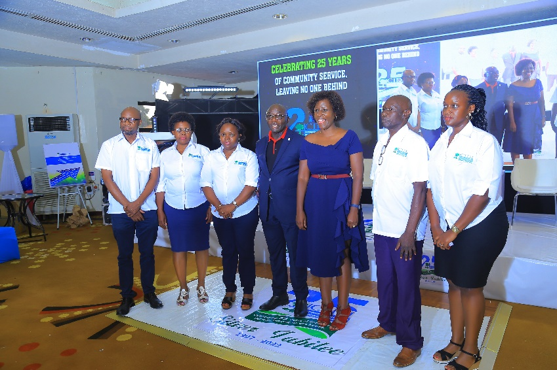
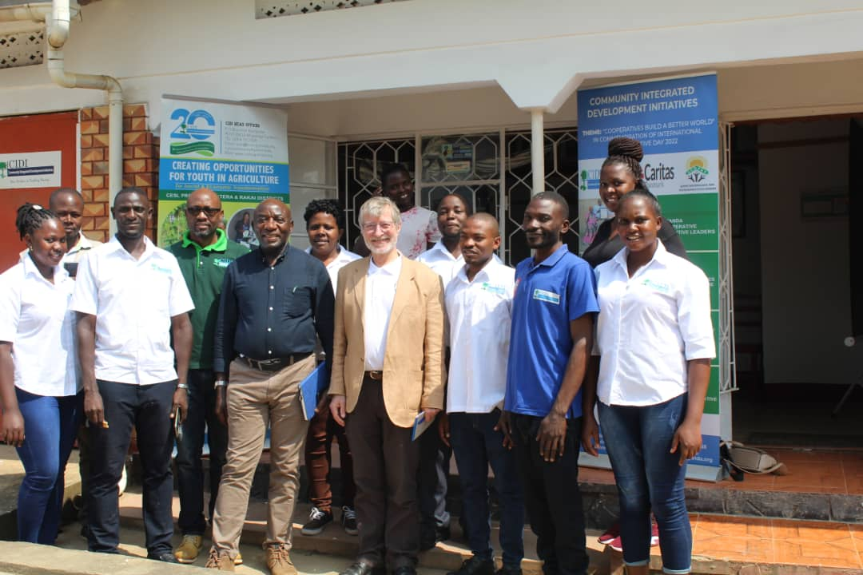
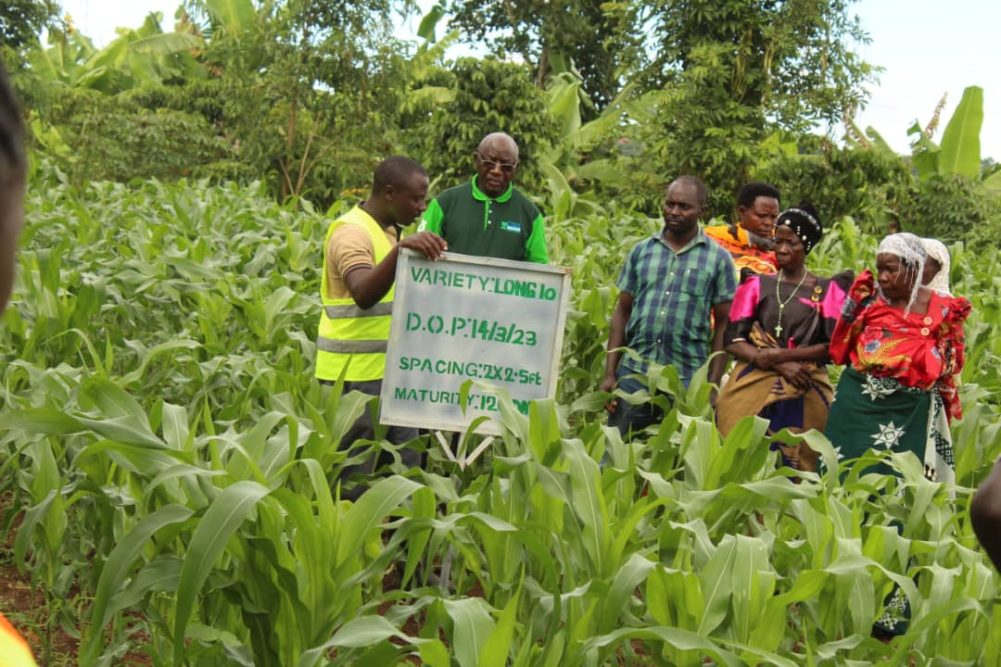
One of the donor visits in Rakai, CIDI field office
Dr.Jjuuko (In green T-shirt) during some of the monitoring visits in Sembabule
The CIDI Senior Management Committee
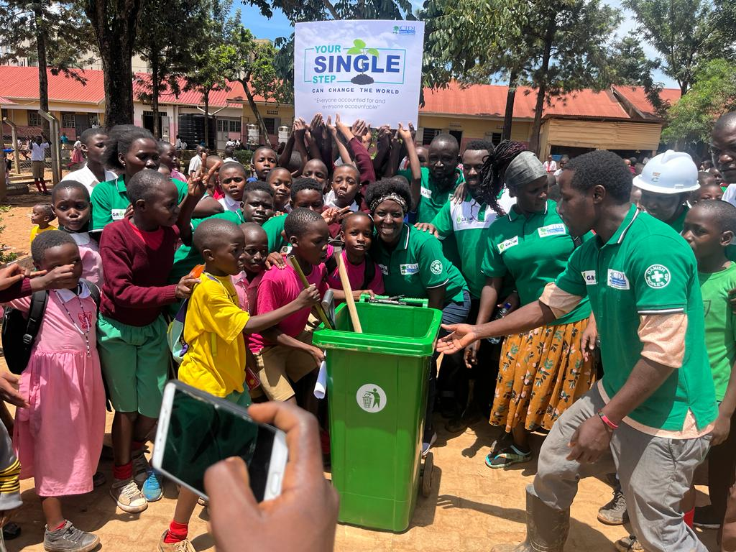
POLICY ADVOCACY AND GOOD GOVERNANCE.
Pupils and Teachers of Luzira Church of Uganda P/S receiving cleaning tools from CIDI during Earth day celebrations.

CIDI has over the years continued to work towards enhancing the capacities of the citizens to demand for improved service delivery. Strengthening capacities of the duty bearers to respond to the needs and demands of the right holders, influence policies and regulatory frameworks that are inclusive and respond to the experiential needs of the communities /citizens has also been key in its undertakings. Strengthening engagement channels for meaningful interactions between the rights holders and duty bearers as well as harnessing strategic alliances is always pivotal for the policy advocacy arm of CIDI. Grounded on the four strategic objectives shaping the departmental strategies, CIDI has undertaken a number of activities to realize the 2022 annual targets as described below;
Strengthened Citizen’s and Civil Society capacity to engage key duty bearers and service providers on issues as well as provision of service delivery in WASH, Health, Sustainable Agriculture & Green growth.
CIDI recognizes the value of purposive empowerment of communities to speak up about the issues affecting them. During the reporting period, CIDI through its community established structures was able to substantially build the capacity of 20,969 community members in the areas of advocacy and lobbying. Through various engagements and training, these have improved knowledge on their rights, entitlements and responsibilities as well as understanding of the government planning and budgeting cycle and relevant policies and laws.
In the year 2022, CIDI’s efforts to use Citizen-led advocacy have resulted in the organization of citizens into 17 advocacy structures within the National Youth Advocacy Platform, under the School WASH and Citizen’s Action on WASH projects within Nakawa. With each advocacy structure having an average of 30 members, these champion community issues and provide a sustainable engagement pathway within the communities as they engage the relevant duty bearers. They have subsequently been able to influence the Youth legislative Agenda within the Parliament of Uganda. At the Local level, the advocacy committees in Nakawa have engaged National Water and Sewerage Corporation and have since received additional water points and repair of broken pipes in their communities and have been able to engage on various issues including tapping into existing government programs.
It's critical to note that awareness creation is a key factor in building the confidence of citizens to engage the duty bearers. Over 4,600 learners (3,350 girls and 1250 boys) 80 with special needs had their capacity built-in aspects of good hygiene practices, Psychosocial support and response to COVID-19 shocks and Menstrual Health Management. These learners have not only taken on the mantle of peer-educating others but also advocating for improved WASH services in their respective schools. As of the reporting period, 6 schools in Nakawa Division had already developed WASH plans for their schools. These efforts have had a cascading effect on 175,965 community people who have gained increased knowledge of existing policies and laws (part of these are NYAP members).
The onset of COVID-19 greatly affected the education sector. Hinging on CIDI’s theory of change for her advocacy efforts, School WASH advocacy and specific investments were made to improve the Menstrual Hygiene Management of over 100,000 learners. These include; the provision of eight (8) tanks (each 10,000 liters), the construction of 7 changing rooms, and 7 incinerators within the primary schools of Nakawa.
Strengthened capacity of duty bearers to respond to the needs and demands in WASH, Health, Sustainable Agriculture & Green growth.
During the reporting year 2022, CIDI strengthened the capacity of 580 duty bearers in understanding Human Rights Based Advocacy (HRBA) to have them respond to their community needs. Since CIDI pursues evidence-based advocacy as one of the working approaches, 2 documentaries were produced on the climate-WASH nexus in schools and the impact of climate change on communities. A citizen’s report card on School WASH in the face of COVID-19 was developed and a policy brief was generated therein. This was shared with the relevant decision-makers at the National, subnational, and local levels. CIDI also had deliberate efforts to popularize the Menstrual Hygiene Strategy and school WASH guidelines among school administrators. These utilized that knowledge to build their compliance with the National WASH standards. Subsequently, there have been improved advocacy results with 18 issues being adopted within the Youth Legislative Agenda and National level budget and Policy processes.
Strengthened engagement channels between right holders and duty bearers.
One of CIDI’s strategies that underpin its advocacy efforts focuses on strengthening engagement channels and creating key linkages between the right holders and duty bearers. This has been achieved through media engagements, dialogues, and advocacy fora among others. In the year 2022, several press conferences and media appearances were conducted and 13 appearances were made in the newsprint. Dialogues were conducted in collaboration with the Ministry of Water and Environment during Uganda water week focusing on climate change financing with key asks around adaptation financing. During the earth day celebrations in Isingiro, inter-generational conversations were held on the effect of climate change on food production, climate effects on refugees and school-going children with a call to action for climate financing for adaptation. The youth fireplace enabled the discussion of limited opportunities for Youth to benefit from the proposed budget of 2022/2023 and the need to use their voices to influence inclusive budgets. The issue of school feeding, cost of water in institutions particularly schools and Health care facilities, and skills for youth have been very prominent within the reporting period. As a result of empowerment and meaningful engagements, CIDI-supported teenage mothers’ and fathers’ groups were able to tap into government programs, accessing a total of 11 million as seed capital. And one of the teenage mothers’ groups was fully registered as a Community-Based Organization at the sub-county, this is key in working towards self-sustainability.
Influencing the Policy and regulatory framework in WASH, Health, Sustainable Agriculture & Green growth.
In the year 2022, CIDI joined several coalitions and platforms as a way of building relevant networks and collaborations. CIDI has a focal person for Civil society Organisations in Uganda under the Sanitation and Water for All (SWA) framework. SWA is a UN framework focusing on SDG of the Sustainable Development Agenda. Under the SWA initiatives, CIDI was able to participate in the joint sector Ministers Meeting in Indonesia in May 2022, which looked at turning the health (pandemic risk), Climate and Peace risks into a triple win through unlocking key barriers for improved WASH services key commitments include:
a. Ensure that political leadership across different branches of government prioritize water, sanitation, and hygiene within national, regional and global agendas, as part of achieving overall social and economic development;
b. Support reforms to aid a stronger enabling environment which contribute to recovery as well as expanded and improved access to water and sanitation, and foster long term resilience as well as financial attractiveness and efficiency.
c. Harness innovative ways to secure resources to cover the costs of ‎the pandemic while kick-starting economic recovery and a green economy, and simultaneously supporting increased investments in water and sanitation to mitigate ‎and adapt to the impacts of climate change;
d. Promote accountability as a central tenet for accelerating sustained progress, strengthening collaboration, reinforcing inclusive participation, and building resilience; especially through sharing information and ensuring transparency to meet commitments and obligations.
During the water week in Stockholm, CIDI made a presentation that shows the importance of getting community voices in the WASH improvement dialogue as well as the key importance of multi stakeholder engagements.
CIDI has built alliances with key partners like the Parliamentary Youth Forum, Parliamentary Forum on WASH , CSBAG and UWASENT and key issues have been adopted in the budget and the Youth Legislative Agenda. The District Local government of Isingiro committed on tree planting bi-laws with in their villages as a way of mitigating climate change. Below are some of the departmental pictorials;
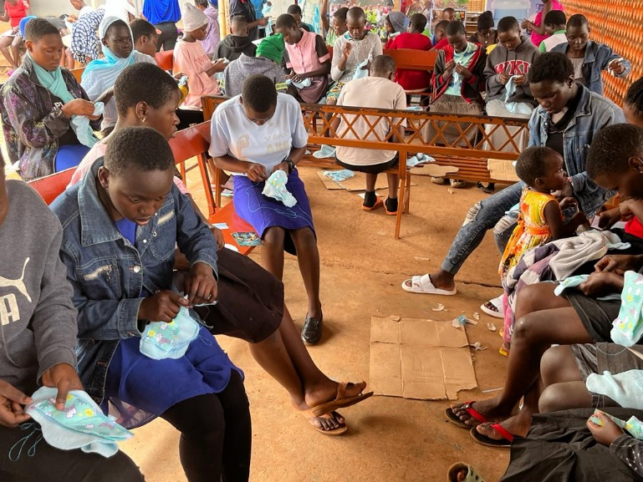
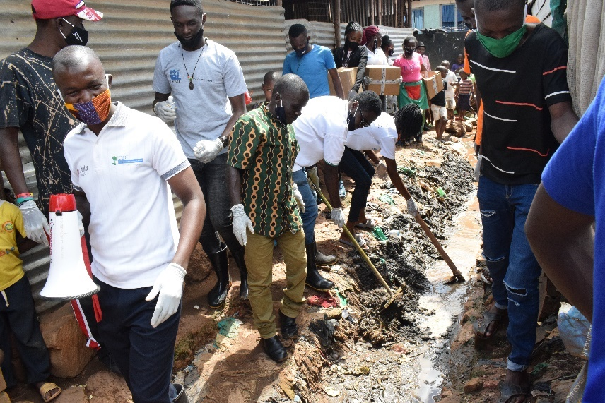
Community clean-up services led by a CIDI advocacy structure in Nakawa division.
Some of the youth learning to make Sanitary pads as part of the CIDI’s MHM initiatives

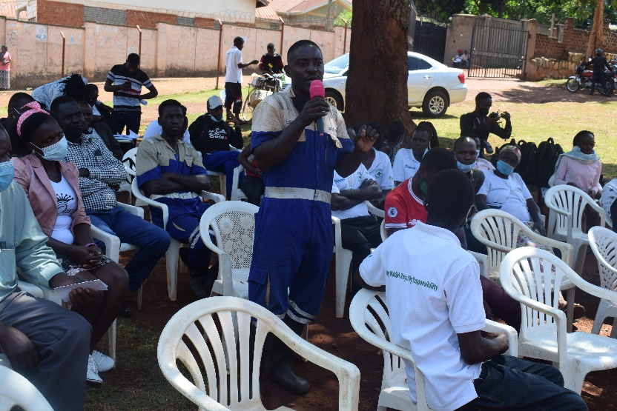
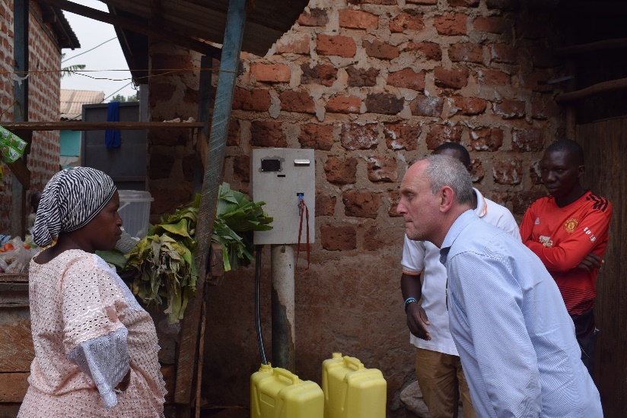
DPA donor visit to one of the pre-paid meters in Mbuya received as a result of CIDI’s advocacy efforts
A staff of NWSC responding to issues raised by citizens of Luzira during a community dialogue organized by CIDI.

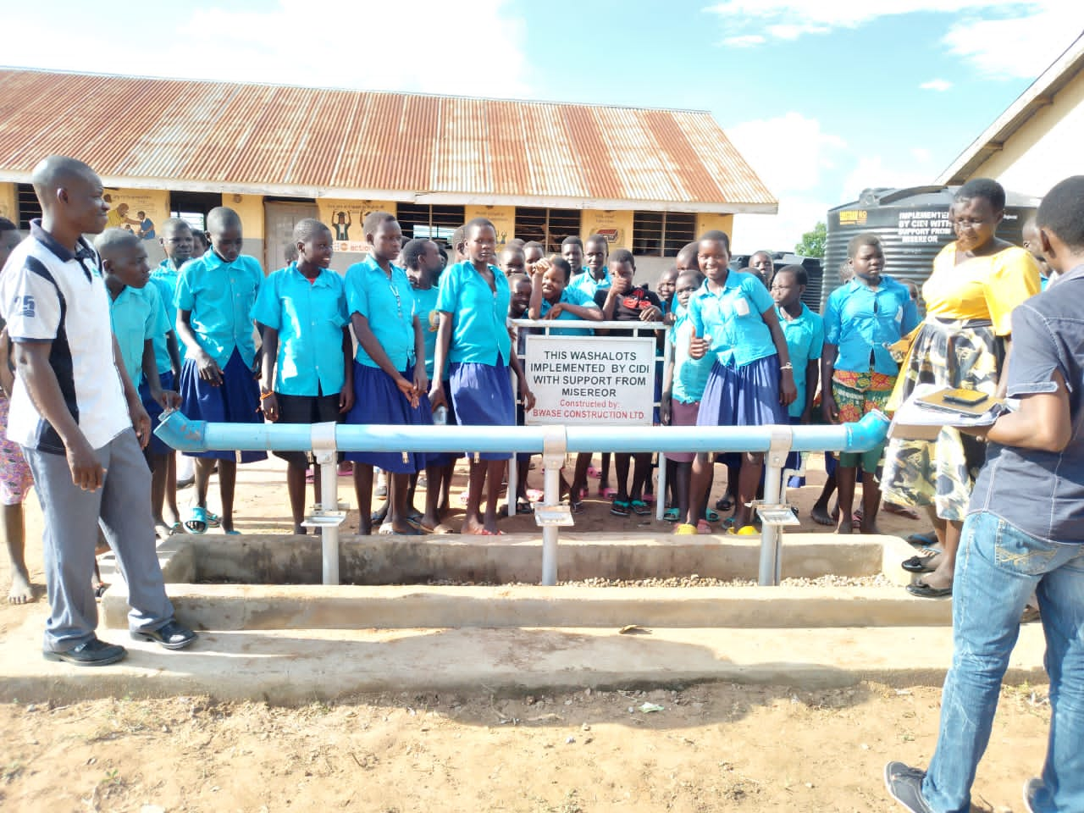
WATER, SANITATION, AND HYGIENE IMPROVEMENT DEPARTMENT

Pupils of Mugongo Primary School in Kyengera Town Council pose for a photo before a CIDI instituted WASHaLOT in their school.

Water, sanitation and hygiene is one of CIDI’s key programme areas. During the year 2022, CIDI has continued to expand her Water, Sanitation and Hygiene interventions in both urban and rural communities especially within informal communities of Kampala, Kyengera Town council in Wakiso district, and within the marginalized poor in Nakapiripirit and Katakwi districts. The department aims at contributing to improved livelihoods of poor communities by increasing their access to clean water and improved sanitation. CIDI’s interventions in WASH are undoubtedly important and equally relevant to both the target communities and the Government of Uganda’s National goals of improving access to adequate sanitation and reducing the incidences of water and sanitation-related diseases.
CIDI’s WASH program interventions during 2022 have mainly focused on; Community mobilization and participation, sensitization& empowerment, integration, Community-led Total sanitation, Child to child, Participatory hygiene and sanitation transformation, community sensitization and empowerment, public-private partnerships, networking and collaboration with other local government and other sector actors, among others. Given the various WASH interventions that CIDI has undertaken, CIDI is now among the leading indigenous NGOs synonymous with WASH, particularly among marginalized communities.
Increased awareness among 1,200,000 beneficiaries in communities and institutions in aspects of WASH, DRR, conflict resolution and advocacy by 2025.
CIDI delights in empowering communities and institutions with knowledge so that they realize their desired changes. A number of awareness initiatives were taken in this regard to sensitize communities and institutions in aspects of WASH, Disaster Risk Reduction (RDD), conflict resolution, and advocacy. During the year 2022, 14 functional school sanitation clubs were instituted by CIDI in areas of Kyengera Town Council, Loregae and Namalu subcounty in the new district of Nakapiripirit and Ngariam in Katakwi district. These were facilitated with Sanitation tools which are very handy in sanitation promotion so that they undertake WASH campaigns at schools and in communities. Overall, 5,260 learners in 14 schools were sensitized about WASH and its related aspects during the year 2022. The CIDI enrolled Peace Ambassadors (45) in the West Nile border districts of Katakwi and Nakapiripiriti were fully trained in aspects of peace and conflict resolution. These have engaged in several peace-building activities within their respective communities and as a result of their efforts, 1,095 direct community members along the border districts are existing harmoniously and knowledgeable about DRR and conflict resolution. These have throughout the reporting period engaged in dialogue meetings with their neighboring communities over communal resource management and DRR.
Improved access to clean and sustainable safe water and improved sanitation services to about 900,000 people by 2025.
Access to clean water and sanitation is a right of every Ugandan and a global Sustainable Development Goal. During the year 2022, CIDI’s interventions in areas of WASH have basically focused on improving people’s access to; water infrastructure (domestic and water for production), Sanitation infrastructure, and Fecal sludge management. CIDI’s establishment of the new solar-powered schemes which are the most sustainable & efficient form of supplying water to big communities has contributed to an increase in the number of households accessing clean water within 200m from the water point from 25% to 30% among the target communities of Nakapiripiriti and Katakwi districts. There has been the establishment and rehabilitation of boreholes along with the provision of new rainwater harvesting tanks in schools and health centers. The rehabilitation of the CIDI-constructed valley dam that had silted contributed to improved access to water for animals and production among the target communities of Nakapiripiriti District. CIDI has also been intentional about proper operations and maintenance of all its WASH-established investments, especially the boreholes, valley dams and solar-powered schemes. User committees in this response were formed and effectively trained on their roles and responsibilities of undertaking proper O&M practices for the facilities under their care. These have played a great role in ensuring the sustainability and functionality of the CIDI-established WASH investments during the course of the year.
CIDI has during the year 2022 been strategic in overhauling kitchens in her target schools. This was intentionally done to create clean and hygienic kitchens for food preparation. With the active participation of various stakeholders within these schools, 40% of the kitchens were rebuilt. WASH through the establishment of WASHaLOTS in 10 schools has been undertaken to ensure hygiene promotion among learners through handwashing. Sanitary facilities like VIPs, Incinerators, changing rooms, and placenta pits have greatly contributed to improved sanitation in schools and health centers. These facilities are very handy in terms of the management of menstrual waste materials and in post-birth management. CIDI’s interventions in schools have contributed to increased enrolment, retention, and performance, mainly attributed to the improved wash environment in the target schools. Some of the beneficiary schools have reported some savings in energy used by about 3% attributed to the energy-saving stoves that were installed in some of the schools. Savings have also been reported on the water bills attributed to the rainwater harvesting tanks that were established in some of the schools and health centers.
Overall, 98 functional WASH facilities have been established in the year 2022 and these have improved access to safe water and sanitation services to 26,211 community and institution members across all CIDI’s target areas of intervention.
Improved life skills and incomes for about 300 youths and women entrepreneurs through green jobs by 2025.
Having commissioned the Fecal Sludge Treatment plant in March 2023, the environmental sanitation in the communities has improved, and employment for about 51 youths and women have been created. These are employed as plant operators, plant technicians, Guards, Marketers for manure, Truck operators, Drivers, Turnboys, Office administrator, Plant Manager, and a plant Engineer. They have been equally trained in green energy enterprises like the use of solar, Bio-gas and ECOCA cooking stoves and are earning on average UGX 900,000 per month. An assessment of their livelihood improvement status revealed that these youth and women have had an improvement in their standards of living as they are able to afford to have 3 meals per day, able to support their children/siblings with school fees, and are now dwelling in clean and healthy environments.
The plant has through the year been able to efficiently treat sludge amounting to 5,500 cubic meters. This has been achieved through private companies or fecal sludge transporters that have been utilizing the mini FST plant. CIDI has throughout the reporting period worked with 20 private companies or fecal sludge transporters to ensure proper waste management in communities. The department has however experienced some challenges that have stalled its interventions and these include; Covid 19 which had far-reaching effects, especially regarding contributing to alarming levels of poverty among the target population this created a slow adaptation to some of the interventions especially those that have financial implications on the schools and households. Escalating commodity prices which have had far-reaching effects, especially concerning increasing the cost of construction. Insecurity in Teso and Karamoja as a result of cattle raids was a challenge at some point but these have now been contained. Below are some of the departmental pictorials;

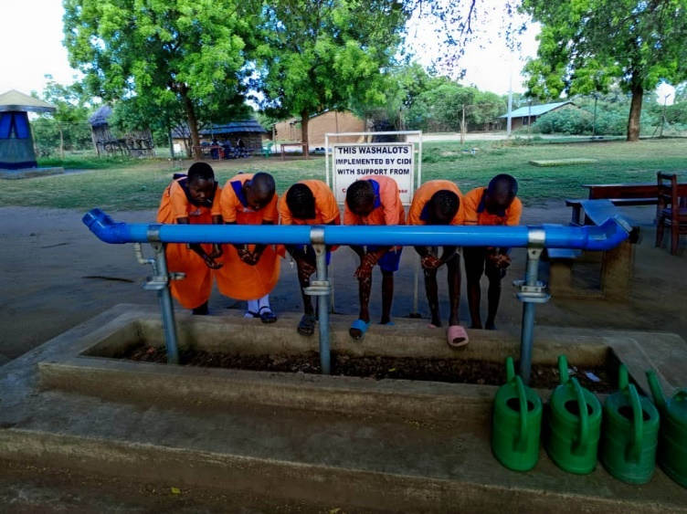
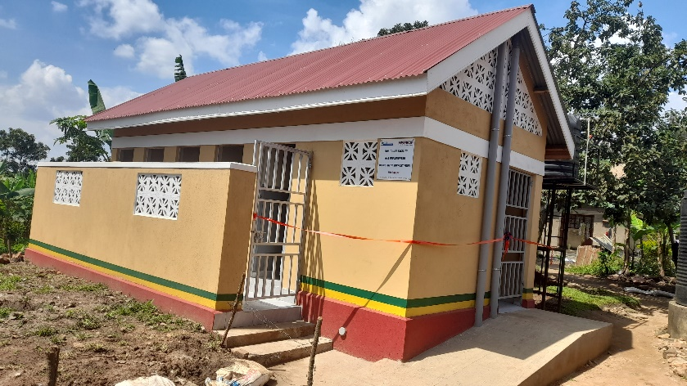
Pupils of Napiyanaya primary school in Loregae sub county Nakapiripirit District wash their hands from a CIDI-established WASHaLOT
A waterborne toilet constructed by CIDI in Mugongo P/School in Kyengera Town Council

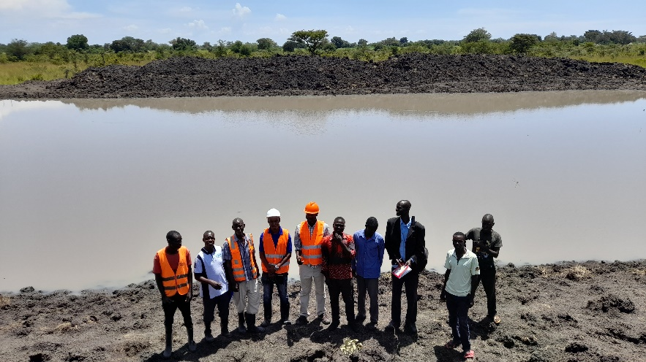

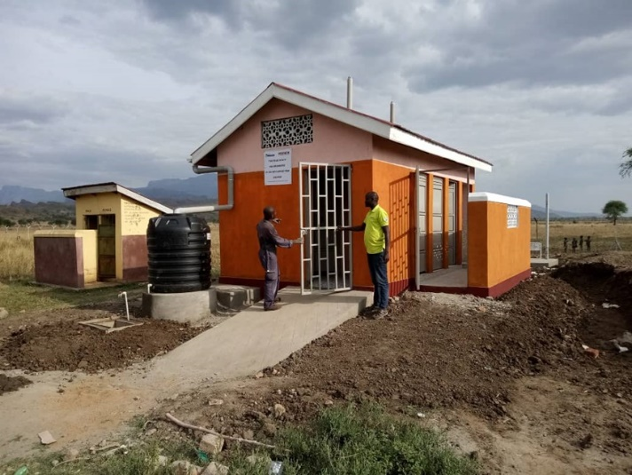
Achanga valley Dam constructed by CIDI in Ngariam sub county, Katakwi District

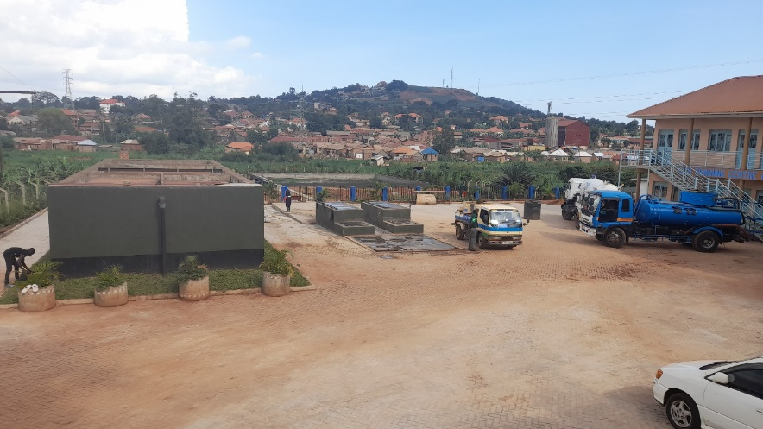
A VIP toilet constructed by CIDI at Nabulanger health center II in Loregae sub county Nakapiripirit District

The CIDI established Fecal Sludge treatment plant in Kabojja

One of the CIDI rehabilitated school kitchen

SUSTAINABLE AGRICULTURE AND GREEN GROWTH
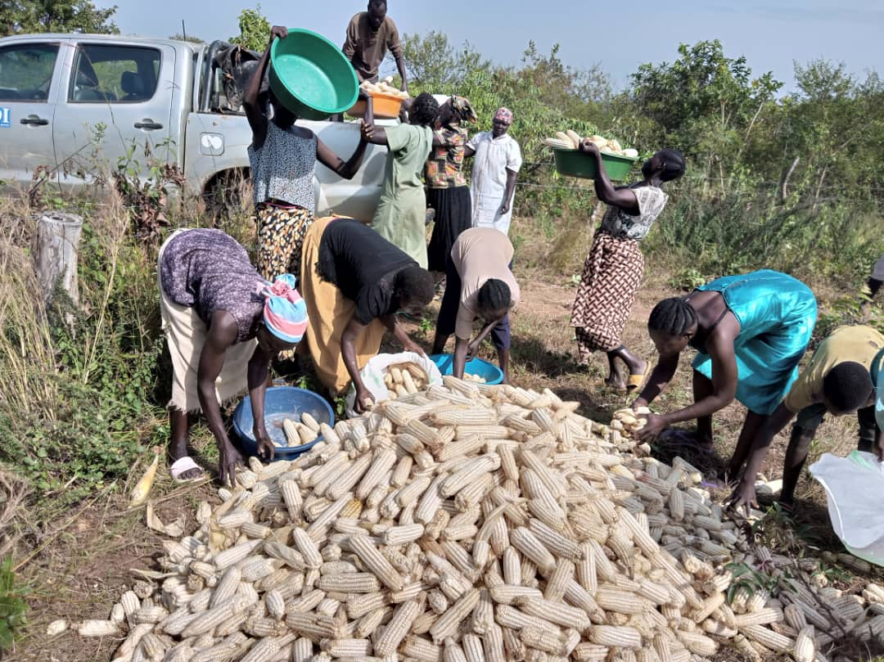
Community-Led School feeding program in Bidibidi Refugee Settlement. Parents harvesting maize from Kodejje primary school garden.

LokoKo
The CIDI Sustainable Agriculture & green growth thematic area is aligned with the Global Planning Framework and contributes to a number of Sustainable Development Goal (SDGs); No Poverty, Zero Hunger, Affordable Clean Energy and Climate Action. The thematic area is one of the major areas that form part of the bulk of CIDI’s program. For the year 2022, this department has been implementing a keynote projects that include; The Soroti Integrated Development Project (SIDP) in Soroti, The Community Empowerment for Sustainable Livelihoods (CESL) in Kyotera and Rakai, The Sustainable Environmental Agro-Solutions in Soroti (SEAs), and the Agriculture Support Services Project (ASSP) in Buliisa, Resilience and Livelihoods improvement Programme, school feeding, and child protection in Yumbe District. In order to achieve the departmental strategic goal of contributing to the economic empowerment of communities through: improved agribusiness investment, youth, and women inclusion, integrated climate change adaptation and resilience by 2025, a number of interventions were undertaken to realize it. Guided by the four planned objectives these include;
Transformed and Strengthened farmer organizations into strong private firms by 2025.
During the year 2022, there were deliberate efforts to transform the already existing 6 youth associations into functional farmer cooperatives. The strategy mainly targeted the youth associations in Soroti and Rakai-Kyotera since these were not registered by the Ministry of Cooperatives but rather at the district level under the District commercial office. A number of capacity-building training to the association members were carried out to ensure a sustainable transformation of these associations into cooperatives. Some of the training include; leadership and cooperative management, records keeping and management among others. Several meetings were held in this regard and at the close of the reporting period, the 3 youth associations in Rakai and Kyotera had successfully organized the relevant requirements to kick-start the registration process as cooperatives. These registration documents were submitted to the Ministry of Cooperatives, while the 3 youth associations of Soroti are still undergoing capacity building and are hoping to transform by the next reporting period of 2023.
Mentorship sessions have been undertaken, Farmer Organization peer-to-peer learning, relevant FO policies developed, and audit exercises and AGMs have regularly been conducted.

Increased agricultural production, Value addition, Bulking and Collective Marketing among 50% of the targeted farmer households through their farmer organizations by 2025.
There have been initiatives during the reporting period to build the capacity of farmers in collective marketing and value addition. This has been through the provision of training organized for FO members in quality standards assurance in order for them to get UNBS product certification for; Wine, Yogurt, Coffee powder, Honey, sorting of cereals, such as beans, cow peas, and milling of pure-white cassava floor. Further efforts have been geared towards strengthening extension service delivery through the CFs/CBTs and LG Extension workers. These have supported farmers in accessing quality seeds to enhance production and productivity. During the reporting period, 1,191 farmer households bulked and collectively sold their produce/ products (280 tons of produce) through Farmer cooperatives. The produce include; Coffee, cassava, sorghum, ground nuts, maize, and sunflower as further portrayed in the chart below;

Source: CIDI-supported Farmer Organization records.

5 of the 8 CIDI Farmer cooperatives provided value additional services to over 1,410 member households in terms of honey processing and packaging, winemaking and packaging, Coffee hulling, processing maize, and cassava into fine flour and packaging it among others. This was possible through conducting mobilization and value-addition planning meetings with value-addition committees and Cooperative marketing officers. Plans for the 3 Cooperatives in Soroti and Kyotera-Rakai that have not been providing value-addition services to their members have been developed to include the provision of value-addition equipment, overhauling the old machines, and replacing the old engines. These will serve a good purpose in adding value to farmers’ produce on top of the work that has been done by the 5 cooperatives.
Through the work of CFs/CBTs and LG Extension workers, 2,996 farmer households were able to access agricultural extension services during the year 2022. CIDI realized this achievement by deliberately ensuring Farmer Organization linkages with Local governments and other stakeholders who can provide extension services, facilitating Cooperative based Farmer Field Schools and conducting on-site training for the CBTs/CFs. The CIDI supported FOs in Rakai-Kyotera and Soroti were able to secure signed MoUs with off takers. There were numerous efforts made towards this attainment and these include; training FOs in contract farming and marketing, facilitating linkages between the FOs and potential business companies/institutions.

CIDI through its strategic actions was able to organize farmers in Soroti district under SEAs project into 15 functional VSLAs. These initiatives have been managed at group Level and they are providing quick and accessible financial services to the Farmers. Plans have been made in the reporting period to upgrade the group model to a functional SACCO. During the year 2022, CIDI farmer institutions (CESIL, SIDP FOs, SD=HS) received a total fund of UGX 149,300,000 in form of grants, agricultural in-puts and cash as seed capital from government, private sector, CSOs, or other development partners like ACDP, UGACOF/NDUNGU Marketing Network.

Increased food and nutritional security and household incomes among 85% of the program H/H beneficiaries by 2025.
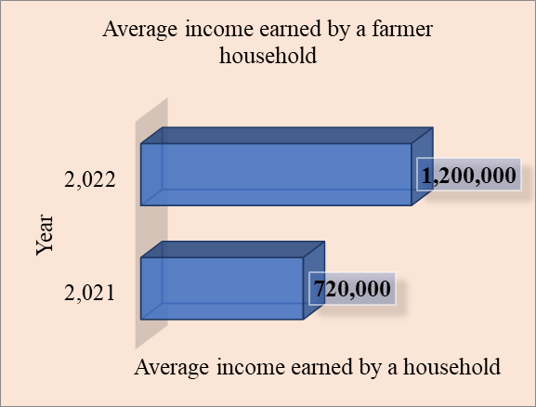
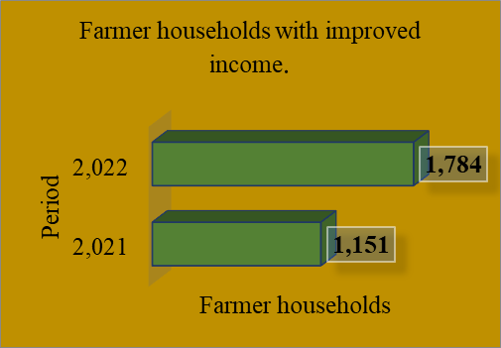
Through the community-based trainers and facilitators, a number of actions were taken during the year 2022 and 1,963 farmers in the beneficiary households adopted Good and Sustainable Agricultural Practices (GAPs & SAPs). This was possible through SAPs competitions which were conducted, Learning and exposure visits made and training in organic fertilizers application. There were also considerable efforts made in Soroti district to ensure that beneficiary households deal in improved animal breeds. 196 farmer households were able to benefit from this initiative as they were provided with improved breed Boer goats. CIDI focuses her interventions on household income improvement for its beneficiaries, 1,784 households in Soroti, Buliisa, Rakai and Kyotera districts were recognized to have realized an improvement in their incomes as a result of farming enterprises. Results from the CIDI annual assessment on household incomes reveals that there is a significant improvement in the average income earned by a CIDI supported farmer household from UGX. 720,000 in 2021 to UGX.1,200,000 in 2022. On top of this, there was an increase in the number of households with improved income from 1,151 households in 2021 to 1,784 households in 2022. These statistics are further displayed in the charts below;
Source: CIDI-supported Farmer Organization records.

Overall, 1,637 beneficiary households were able to access three meals per day during the year 2022. The strategic deliverable was realized the adoption of SAPs and GAPs that led to increased food production in the farmer households. During the reporting period, 645 youth in the CIDI covered areas were also given training in on-farm and off-farm income generating activities. These include; Wine production, yogurt production, apiary, carpentry, tailoring and shoe making. These have been involved in production of food security crops and horticultural crops.

Promoted climate change resilience among 10 farmer organizations (Cooperatives) annually and 8000 farmer households by 2025.
CIDI has been intentional about her strategic direction of promoting climate change resilience amongst farmers in her areas of operation. During the year 2022, 866 farmers were trained in climate change impacts and environment preservation. These were in position to reach 3,620 other farmers and equipped them with knowledge on climate change mitigation and adaptation. Trainings were conducted in bee keeping, tree planting, ECOCA usage, and SAPs , while the other farmers were trained on environmental good governance, green growth and climate resilience in agriculture production and other development practices. As a result of all these initiatives, 1,497 farmer households have been reported practicing Climate Smart Agricultural Practices. There has demarcation and reclamation of two wetlands in Soroti district as numerous efforts to promote the relevant wetlands has been on the hype during the reporting period. The demarcated wetlands include; Ogolai Arusi Wetland Arabaka wetlands in Arapai sub county. Farmer Organizations were supported to conduct engagements with relevant stakeholders and duty-bearers to ensure realization of Eco- friendly practices as a means of securing the wetlands. 12,800 trees were planted in various project-covered districts like Soroti, Nakapiripiriti, Rakai, Kyotera and Buliisa. This was facilitated by the establishment of tree nurseries, planting and monitoring of planted tree sites along with support from CIDI partners in green growth like Totalenergies, TROFACO. Some of the departmental pictorials;
CIDI supported farmer in Buliisa practicing good post-harvest handling of his cassava.
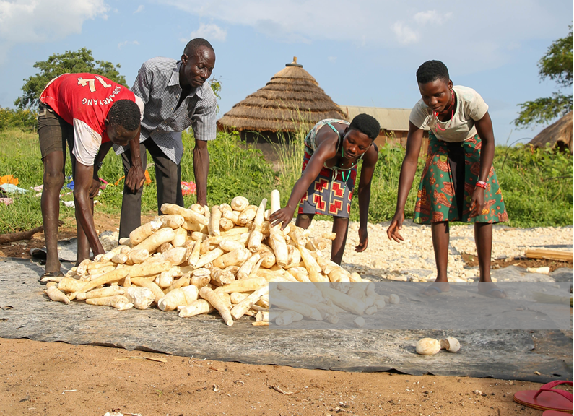
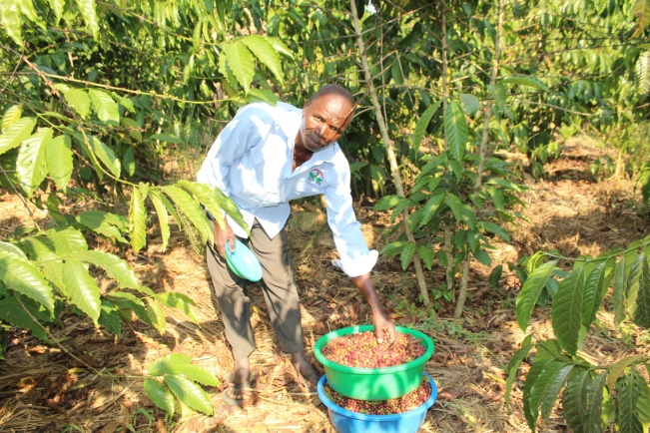
A CIDI-supported farmer practicing good post- harvest handling in Buliisa District.
One of the farmers in the CIDI supported cooperatives of Rakai harvesting coffee.
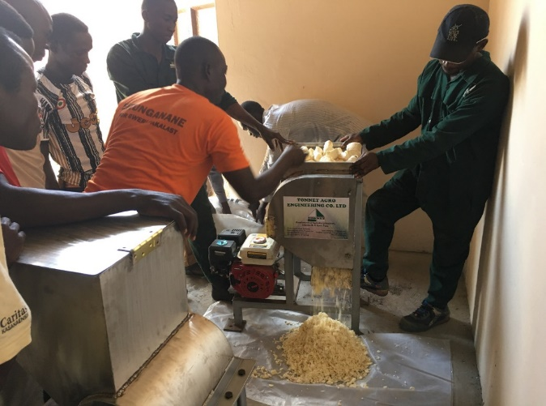
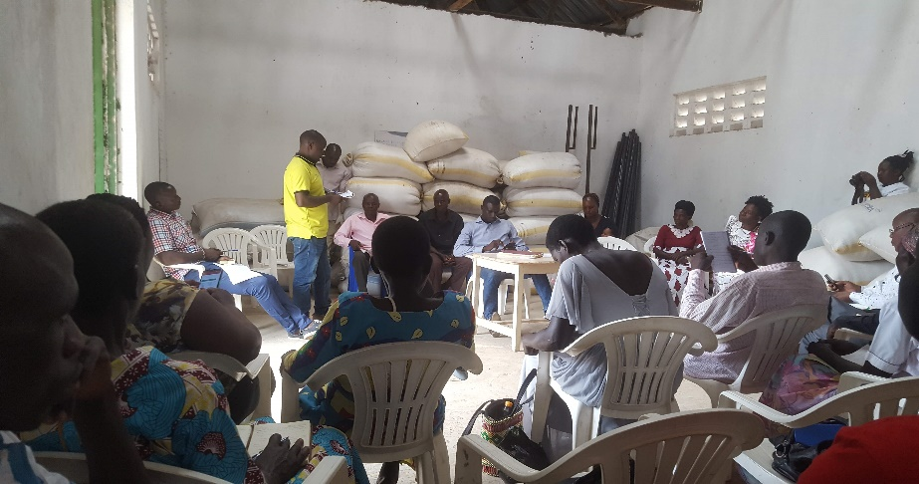
Cooperative members from Rakai using their cassava grater.
Members of Lwanda Cooperative Society sharing their experience with the farmers from the 5 Cooperatives of CIDI Soroti.

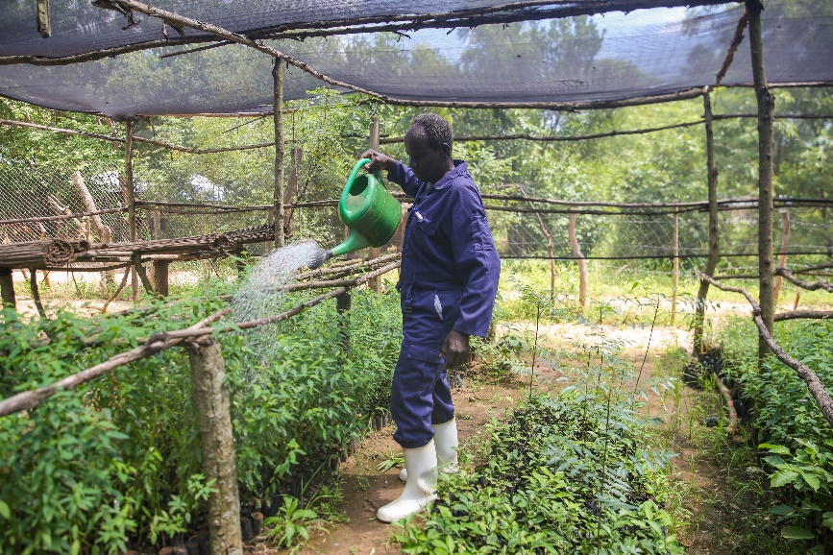
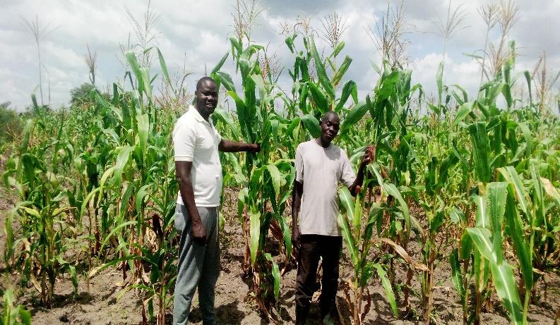

CIDI field officer and Mr.Ejuku (right) in his garden of maize being given technical guidance on maize production.
A tree farmer irrigating trees in a CIDI supported tree nursery bed in Buliisa District.

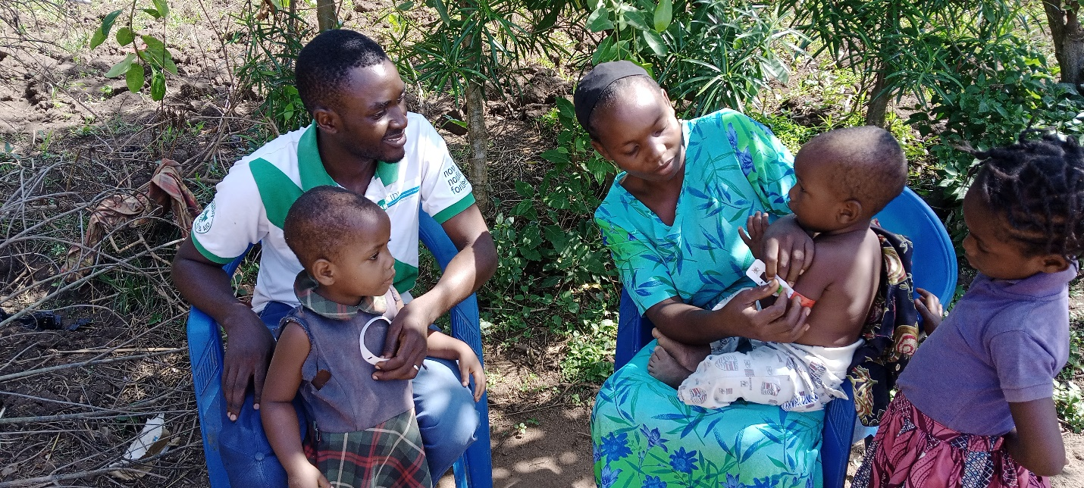
HEALTH PROMOTION
OJOFACOS Farmer cooperative of Soroti training in seed multiplication process for ground nuts. (Katine sub county)
A mother trained by CIDI screening her child for Malnourishment in Kyangwali Refugee Settlement.

CIDI is cognizant of the fact that health is one of the vital areas that contributes to the productivity of an individual and general well-being of people. Therefore, CIDI puts emphasis in the promotion of good health amongst the communities through different interventions. This is done with the main goal of contributing towards improved health, welfare and economically productive communities. Deliberately CIDI focuses towards Improving access, demand and utilization of quality health services among communities as well as taking on preventive measures against diseases.
Capacities of communities built in advocating for their health rights and better health services.
The health department managed to have some advocacy issues responded to by the duty bearer’s right from the district to national level. One of the issues was the fact that the nutrition component did not have a specific sector where it belonged. As a result of the CIDI advocacy efforts, Kabale district committed 9% of its financial resources to cater for nutrition interventions. Over 2,800 people were trained in advocacy and WASH approaches across the districts of Nwoya, Maracha, Kabale and Bugweri. These will cascade lessons learnt to the communities especially on the best practices of hand washing and personal hygiene. Four evidence dossiers detailing the advocacy issues of concern being pursued and their justifications were produced one per district. These evidences are being used to engage the decision makers to cause action on the issues pursued.
Four advocacy forums across the districts of Maracha, Nwoya, Kabale and Bugweri were conducted between the rights holders and the duty bearers with an aim of getting immediate feedback on the advocacy issues presented. One of the issues was ignorance on the right food composition and the number of meals to eat especially in the districts of Bugweri and Nwoya and it was agreed that the DHO should conduct regular sensitizations and education sessions/outreaches to be able to address this concern, this was planned for in the recent budget.
Enhanced utilization of available health services by the communities.
Right to grow commemorated 4 important days in the WASH and nutrition calendar some of these included the World toilet day, Global hand washing day, World food day. These days culminated into press conferences where pressers were presented on the nutrition and WASH statuses of Uganda while calling different stakeholders to action. This has resulted into the parliament gaining interest in WASH especially in health care facilities and pledged to prioritize it. A total of 747 VHTs were trained in the health care approach, they are conducting referrals which has reduced on the severe cases of malnutrition mortalities due to malnutrition. A total of 34,875 care group volunteers and Neighbor women are implementing activities contributing towards improving their livelihoods such as kitchen gardening (1881backyard gardens), Family-led MUAC, Rabbit rearing (60), VSLA savings, Liquid soap making (So far 44 groups were trained in the settlement out of 149).
Enforced uptake of preventive measures towards different diseases.
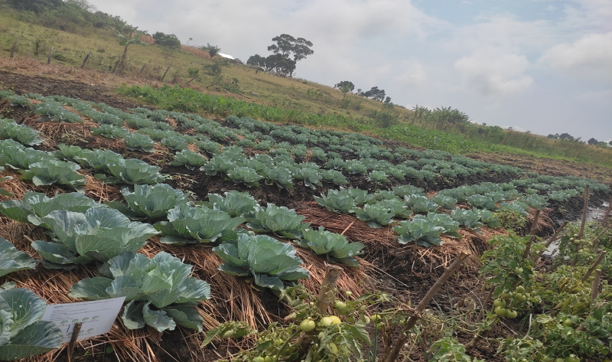
2,430 Households were provided with MUAC tapes as to increase the rate of malnutrition screening in the community, this has reduced on severe cases since they are identified early and referred for further management at the health facilities. A total of 4,275 households have had their capacity built on aspects of nutrition, this was done through home visits and exchange learning visits that were conducted during the reporting period 2022. This helps in replicating best practices to other care groups. The departmental pictorials are as shown below;
One of the kitchen gardens established at the health facilities in Kyangwali Refugee settlement.

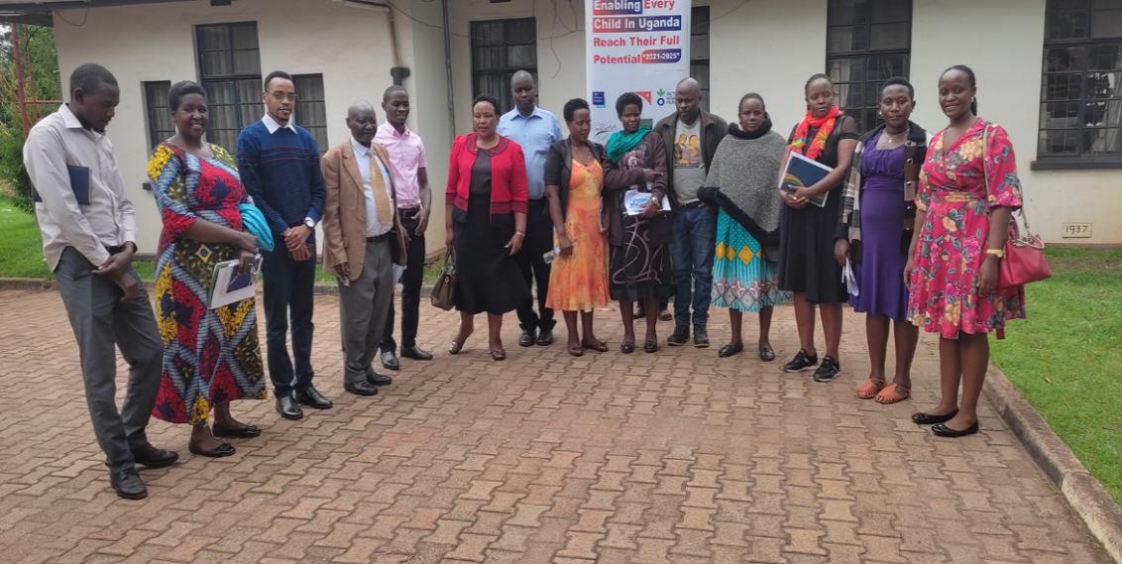
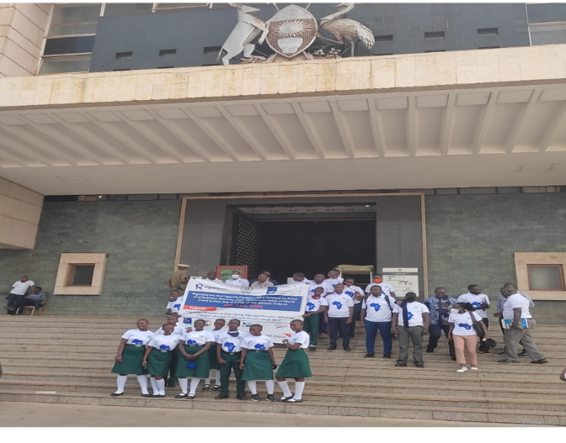

The day of the African child that was celebrated at Parliament of Uganda

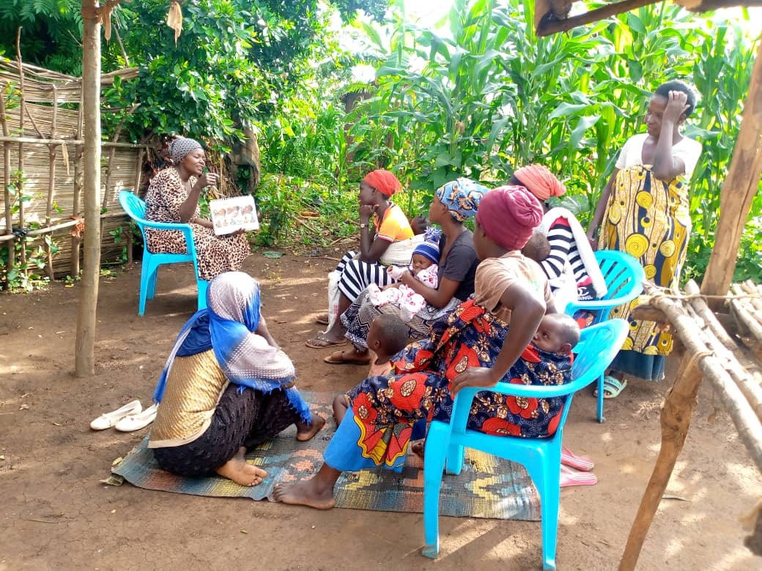

Fact sheet dissemination in Kabale

A Care group volunteer cascading knowledge to her neighbor women in Kyangwali Refugee Settlement

MONITORING, EVALUATION AND LEARNING.
Monitoring, Evaluation and Learning is a key driver in all project operations of CIDI’s interventions. A number of strategic activities were developed to guide the departmental undertakings and also to enable effectiveness in monitoring, controlling, learning, accountability and documentation of CIDI’s work. Below are the two specific objectives that contribute to the goal of the department that aims to Improve efficiency, effectiveness and sustainability of CIDI's programs through generation and use of evidence for informed decision making, learning and promotion of CIDI’s strategic goals.
Organizational capacity built in Results based M&E and documentation among CIDI staff by 2025.
During the year 2022, a set of strategies were developed to guide the flow of activities in the department. A number of indicators that speak to these strategies were also developed so as to aid in measuring achievement of the developed strategies. The success registered on the key performance targets under this objective is attributed to a number of factors that include; Technical support extended to departments and projects that include follow-up on the implementation of their work plans including reviewed reports. These were facilitated by the presence of clear workplans and active involvement of project managers in M&E activities. In order to Improve planning and monitoring of programs, an annual review and planning workshop was held for three days. A refresher dissemination of the strategic plan was done at the start of the exercise to give staff an open view of what is entailed in the CIDI Strategic Plan 2021-2025 document and their required roles to play. A participatory approach was used to enhance involvement of heads of departments and all other staff. The exercise was attended by all CIDI staff, the head of governance, administration and Management alongside other two board members who gave it a better touch of expertise in the various focus areas that were discussed. The guidance given during the discussions and reactions gave a clear sense of direction for the plans that were developed for the year 2023. All departments participated in the review and planning exercise and all their annual operational plans for 2023 were submitted to the M&E department that reviewed them and shared with the Programs Coordinator for compilation and presentation to the board of governors. The M&E department further supported the baseline, midterm and end-line planning and evaluations for projects like the SaWa endline evaluation, Livelihood Restoration project (Buliisa) close-out survey, TCGL endline evaluation and tracer study, and Resilience and Livelihood Improvement Programme baseline (Bidibidi) among others.

70% of the project /program reports were reviewed and submitted on time, based on the donor reporting calendar, and this was attained through follow ups to the project/ program managers by the M&Es to argue for timely compilation of their reports. 50% of staff adhering to CIDI communication guidelines was achieved through collaboration with the CIDI communications officer and the IT manager in ensuring compliance to the CIDI communication guidelines and staff utilization of CIDI email.
Set up a strong M&E system that integrates evidence-based decision making, stakeholder information needs, learning and research and organization visibility.
Three main strategies were formulated to achieve this objective and the factors that facilitated the success recorded under the key strategic performance indicators and targets include; In the Management of CIDI MIS and data use, 2 refresher training by the developer were undertaken for CIDI staff on the Management of CIDI MIS and data use. A thorough system analysis was then conducted by the M&E staff to investigate the reasons why the system failed in the past years. The weaknesses/gaps identified included the system being complex and not user-friendly, always on and off, too expensive to maintain, analysis of data restricted to only MS Excel, and could not be used without access to the internet among others. It was further resolved during the planning for the year 2023 that a new developer for the MIS is identified to design a system that satisfies the organization’s information requirements.
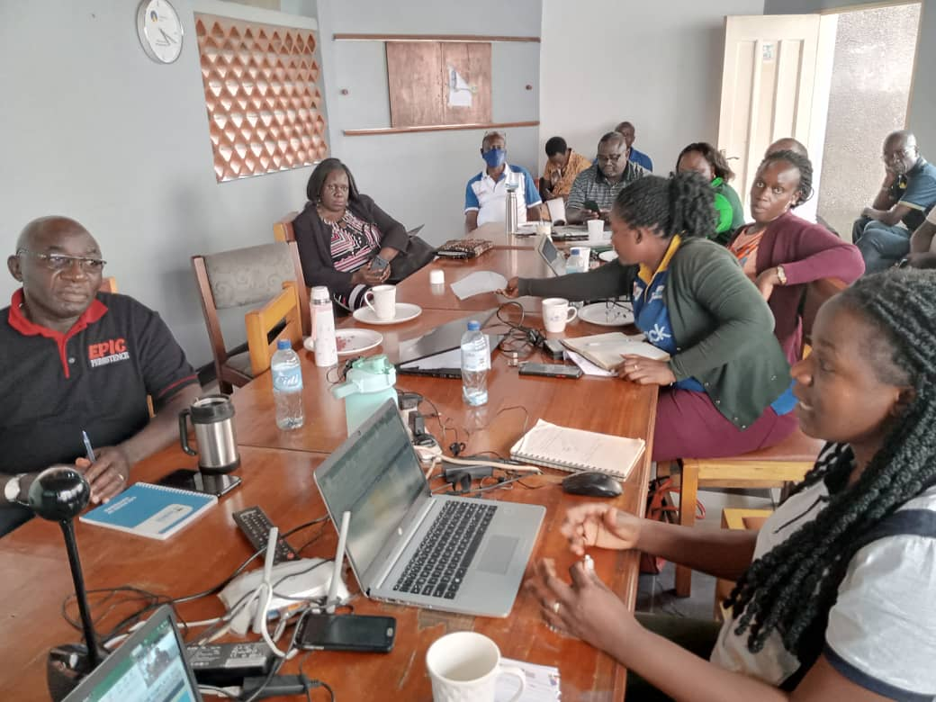
24 project/program success booklets and documentaries were published and this was achieved through the capacity building of project staff on success story compilation by both M&E and other external actors. The CIDI Celebrations for the 25 years also highly facilitated the publishing and capturing of documentaries that showcase what CIDI does in her key focus areas. The community review meetings held were achieved through the involvement of key stakeholders like the district’s local government officials in project development. Some of the departmental pictorials;
CIDI staff attending virtually the annual review and planning workshop of 2022

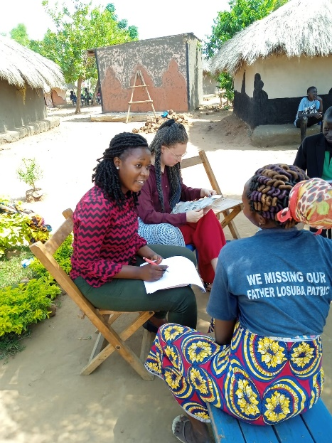
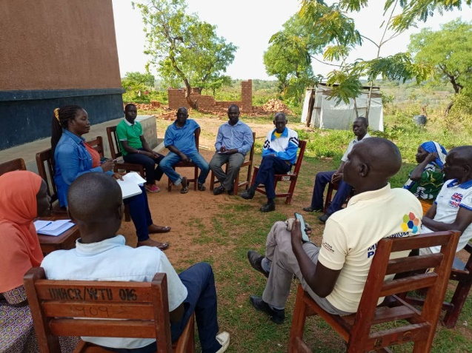
The M&E manager conducting an interview in Bidibidi Refugee Settlement during an internal evaluation.
The M&E officer sharing a focus group discussion in Soroti district.
The M&E manager conducting an interview in Bidibidi Refugee Settlement during an internal evaluation.
CIDI staff attending the annual review and planning workshop of 2022 at the head office
HUMAN RESOURCE DEPARTMENT

Policies, procedures, and systems for effective and efficient HR management were planned and instituted.
During the year 2022, new issues were identified and these include; revising periderms for field visits to suit the rising accommodation prices in most of the upcountry offices. In terms of development and data protection policy, CIDI was able to register with NITA (National Information Technology Authority) in Uganda as a new law in Uganda and Occupational Health guidelines were developed. In line with the dissemination of policies, at least each CIDI branch office has a file of policies and some can be accessed on the CIDI website. Further awareness has been made during the orientation or induction of every new staff and does have areas of discussion during staff meetings. A number of field visits were conducted in Yumbe, Kyangwali, and Rakai districts where more emphasis was put on the different policies like Complaints handling mechanisms, safeguarding and Core Humanitarian Standards.

Improved practices in the recruitment, retention and staff development of staff.

CIDI has through the years delighted in its human resource systems that ensure recruitment of staffs in their rightful positions. This was embraced through the reporting period in a fair manner with transparency. As a result, 9 CBFs, 1 Nutrition officer,1 OHS officer, 2 project officers were recruited for the various projects in Kyangwali and Bidibidi refugee settlement.
With the capacity building plan in place, which forms part of the guiding tool, staff-desired trainings were planned for and conducted in the course of the year. Trainings like Fire and safety training by OHS officer was conducted and certificates were issued, Core Humanitarian Standards training was also conducted for all CIDI staff. Staff competitive packages which include; Salary has been provided during the course of the year, Medical insurance was provided at all levels and Lunch was provided to all staffs.
Staff meetings were conducted routinely where staff issues were raised and resolved amicably on a round table. SMT meetings were also held in the due course of the year with full participation of the members and key issues discussed were documented for action.
All staff files were updated continuously during the due course of the year. This was done by ensuring that every required document for the staff is on File thus exhibiting a high sense of Records management. The 2022 Annual Review and 2023 planning meeting was conducted successfully in conjunction with M&E Department. There has been routine updating and preparing Job Descriptions for staff and making sure these are in line with Project targets in terms of objectives.
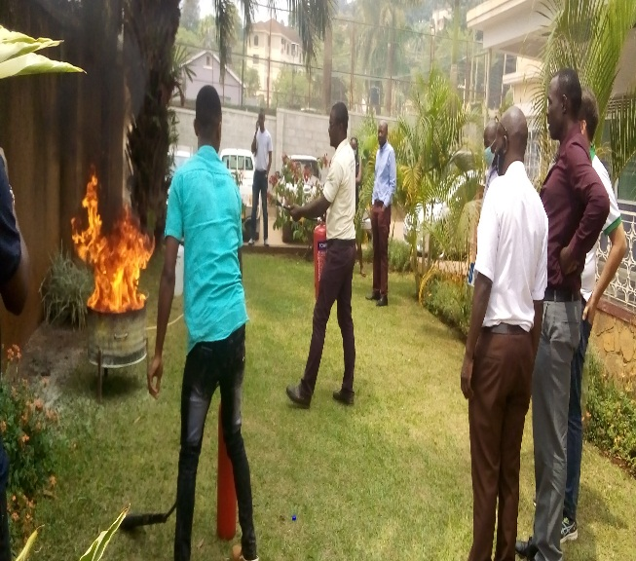
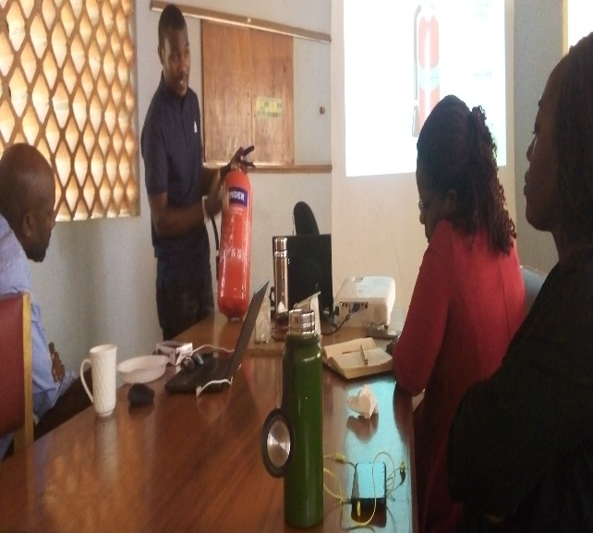
SOME PICTORIALS
Some of the CIDI Staff during fire and safety training at CIDI head office

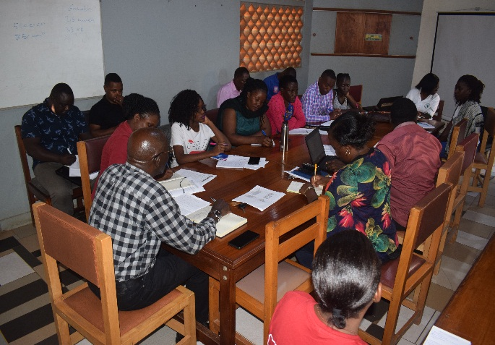
During one of the staff meetings

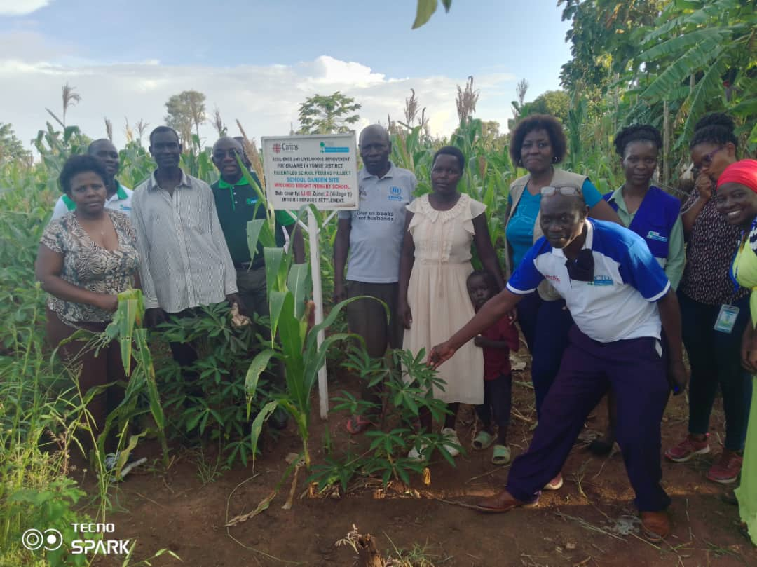
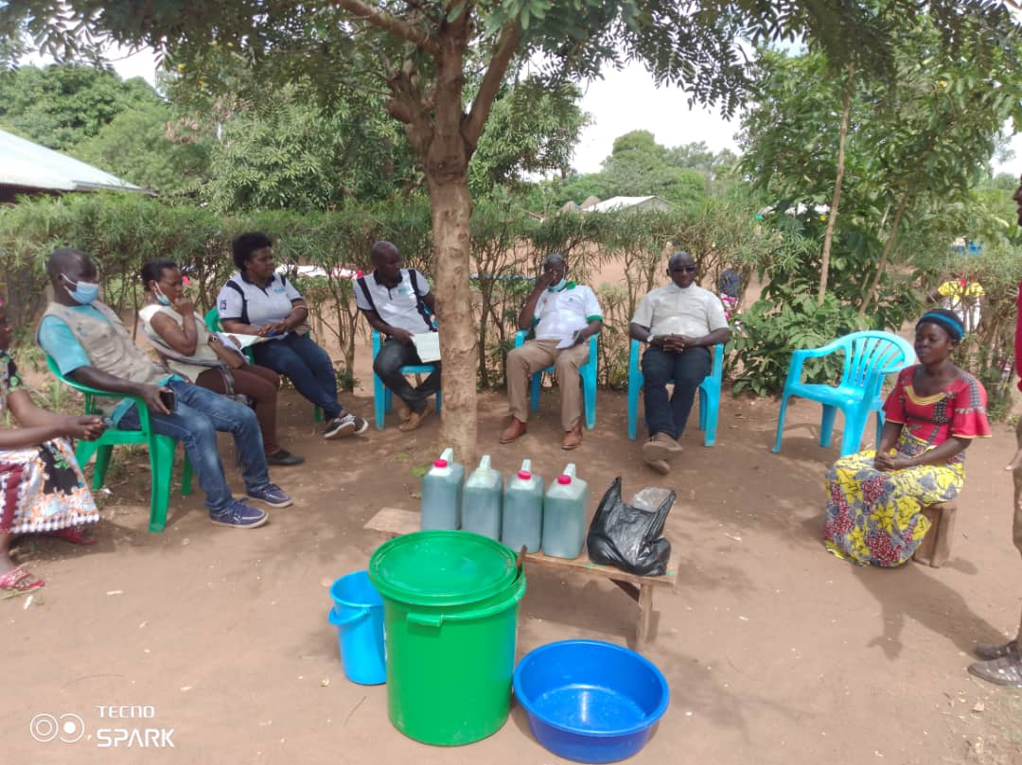
Some of the field visits; Visit to Kyangwali on the left and Bidibidi on the left.

